Nextcloud OpenShift Setup Lessons Learned

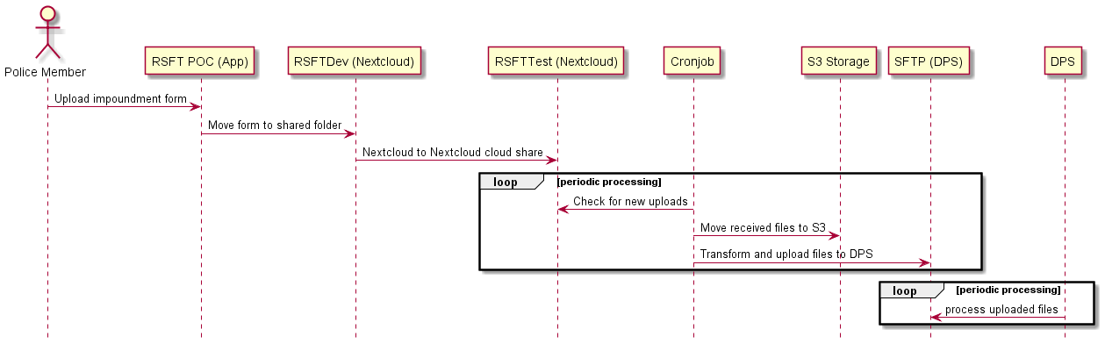

Nextcloud Setup

1. Required container images:
   1. nginx:alpine
   2. ~~mariadb:10.2~~ postgresql:12
   3. nextcloud:12-fpm
2. User brokered authentication using Keycloak
3. IDIR login using Keycloak
4. Keycloak to external OAuth servers (e.g., SaanchPD Office 365) using social login app
5. External storage configuration
   1. DPS integration using SFTP protocol
   2. S3 integration using Amazon S3 protocol
6. Custom app development: RSFT Proof-of-Concept app

Related JIRA Tickets

1. [JHI-1827 RSBC Secure File Transfer Technical Theory POC](https://justice.gov.bc.ca/jirarsi/browse/JHI-1827)
2. [RSI-1561 RSBC Secure File Transfer Technical Theory POC TAC Sessions and Tasks](https://justice.gov.bc.ca/jira/browse/RSI-1561)

Deployment

1. Fork nextcloud-openshift repo: <https://github.com/agahchen/nextcloud-openshift>
2. Create docker.io secret: david-docker-secret
   1. set default 5115cc-dev docker.io credentials as david-docker-secret
   2. oc secrets link default david-docker-secret --for=pull
   3. oc secrets link builder david-docker-secret
3. Set up nginx
   1. Import nginx:alpine: oc -n 5115cc-dev import-image nginx:alpine --from=docker.io/nginx:alpine --confirm
4. Set up ~~mariadb~~ postgresql (Nextcloud did not work with mariadb out of the box)
   1. Existing PostgreSQL instance
5. Set up nextcloud
   1. Config the creation nextcloud.yaml file
   2. Import nextcloud:12-fpm: oc -n 5115cc-dev import-image nextcloud:12-fpm --from=docker.io/nextcloud:12-fpm --confirm
   3. Also import nextcloud:20-fpm: oc -n 5115cc-dev import-image netcloud:20-fpm --from=docker.io/nextcloud:20-fpm --confirm
   4. Create nextcloud app: oc process -f nextcloud.yaml -p NEXTCLOUD_HOST=rsft-dev.apps.silver.devops.gov.bc.ca | oc -n 5115cc-dev create -f –

Operations

1. Nextcloud auto update does not function seamlessly in containerized environments. The auto update will upgrade the database to the latest v20 version. However, the container image is immutable and cannot be updated. This will cause Nextcloud to fail on restart (version incompatible error.) To fix this, manually import latest nextcloud:20-fpm container image from Docker Hub and then restart Nextcloud.

Development

1. Look into Nextcloud PHP API
   1. https://nextcloud-server.netlify.app/
2. OCS API
   1. https://docs.nextcloud.com/server/latest/developer_manual/client_apis/OCS/index.html
3. Nextcloud vs ownCloud – The Whole Story
   1. https://civihosting.com/blog/nextcloud-vs-owncloud/
4. ownCloud vs. Nextcloud: comparing cloud collaboration services
   1. https://www.ionos.ca/digitalguide/server/tools/owncloud-vs-nextcloud-a-comparison/
5. Background jobs (Cron)
   1. https://docs.nextcloud.com/server/latest/developer_manual/basics/backgroundjobs.html#writing-a-background-job
   2. https://nextcloud-server.netlify.app/classes/ocp-backgroundjob-timedjob
6. Nextcloud PHP API
   1. https://nextcloud-server.netlify.app/
   2. OCP\Files\Folder
      1. https://nextcloud-server.netlify.app/classes/ocp-files-folder#method_getDirectoryListing
   3. IAppData Simple Filesystem
7. How create a folder / file in Nextcloud with PHP?
   1. https://help.nextcloud.com/t/how-create-a-folder-file-in-nextcloud-with-php/85409
8. Nextcloud theming
   1. https://docs.nextcloud.com/server/latest/admin_manual/configuration_server/theming.html
9. Nextcloud Workflow
   1. https://nextcloud.com/workflow/
10. Nextcloud Vue Style Guide
    1. https://nextcloud-vue-components.netlify.app/